

(An Autonomous Institute)
Affiliated to Visvesvaraya Technological University, Approved by AICTE, New Delhi
Recognized by UGC under 2(F) & 12(B), Accredited by NBA & NAAC Near ITPB, Channasandra
Bengaluru-560067

PROJECT REPORT ON

“TRAFFIC SIGNALS USING FINITE STATE MACHINES (FSM)”
Submitted as an Assessment For the course on
CNC(AEC)LEVEL-3
Department of Mechanical Engineering
COURSE CODE- MVJ22A6113
Submitted by

CHANNAYYA V METI | 1MJ23VL004
HARISH RAGHUNATHAN | 1MJ23VL007
JEEVAN K HOSAKERI | 1MJ23VL011
KALLUR PRASHANTH REDDY  NANDISH GOWDA B R | 1MJ23VL014  1MJ23VL021

Under the guidance of
Prof. VINOTH KUMAR G
Assistant professor
Department of Mechanical Engineering MVJCE, Bengaluru 560067


MVJ COLLEGE OF ENGINEERING, BENGALURU- 560067
(Autonomous Institution Affiliated to VTU, Belagavi) DEPARTMENT OF MECHANICAL ENGINEERING

CERTIFICATE

Certified that the project work titled "TRAFFIC SIGNALS USING FINITE STATE MACHINE(FSM)” is carried out by CHANNAYYA V METI(IMJ23VL004),HARISH RAGHUNATHAN(1MJ23VL007), JEEVAN HOSAKERI (1MJ23VL011),K.PRASANTH REDDY(1MJ23VL014),NANDISH GOWDA(1MJ23VL021) who are Bonafide students of
MVJ College of Engineering, Bengaluru, in partial fulfilment for the award of Degree of Bachelor of Engineering during the year 2025-2026. It is certified that all corrections/suggestions indicated for the Internal Assessment have been incorporated in the project report. The project report has been approved as satisfies the academic requirements in respect of project work prescribed by the institution for the said Degree.

Signature of Guide Signature of HOD
Prof. Vinoth Kumar G Dr.Srinivas L Gombi
AEC Coordinator – CNC HOD AssistantProfessor, Department of ME Department of ME
MVJ college of Engineering MVJ College of Engi Bengaluru

External Viva
Name of Examiners Signature with Date
1
2

TABLE OF CONTENTS

✅ Structure of the New Report
- Cover Page
- Certificate
- Acknowledgment
- Abstract
- Table of Contents
- Chapters (Main Body):
  - Chapter 1: Introduction
  - Chapter 2: Objectives and Scope
  - Chapter 3: Methodology (FSM Design, Theory)
  - Chapter 4: Design & Implementation (FSM, Circuit Diagrams, Flow Diagrams)
  - Chapter 5: Results and Observations (Working of FSM, Timings, Transitions)
  - Chapter 6: Applications and Use Cases
  - Chapter 7: Limitations and Future Work
  - Chapter 8: Conclusion
- Appendices (if needed)
- Literature Review
- References

Chapter 1: Introduction

Background and Context

Traffic management is a critical component of urban infrastructure. Traditional traffic signals operate on fixed timers or manual control systems, which often fail to adapt efficiently to dynamic traffic conditions. In recent years, the integration of digital systems and logic-based designs has paved the way for more intelligent and flexible control mechanisms.
Finite State Machines (FSMs), a subset of digital logic design, provide a robust framework for modeling complex, sequential processes like traffic signal control. FSMs are widely used in embedded systems and hardware design due to their predictable behavior, simplicity, and ease of implementation.
This project explores the implementation of traffic signal control using FSM principles. It emphasizes how FSM can be effectively applied in modeling the cyclic behavior of traffic lights, ensuring smooth and automated transitions among different signal states such as RED, YELLOW, and GREEN.

Motivation

With the increasing vehicular population and urban congestion, managing traffic efficiently has become more essential than ever. Implementing a systematic, logic-driven approach like FSM in traffic signal control ensures that:
    - Transitions follow a predictable and safe pattern.

    - Hardware designs remain cost-effective and power-efficient.
    - It becomes easy to expand or customize for multi-lane or smart traffic systems.
This project is particularly motivated by the need to demonstrate FSMs in real- world applications using basic digital design concepts learned in coursework.

Relevance to CNC (Advanced Manufacturing)
While the primary domain of FSMs is digital logic and embedded systems, the principles of automation, process sequencing, and control theory strongly align with the core aspects of CNC (Computer Numerical Control) and manufacturing systems. Understanding FSM enables students to design systems that can sequence manufacturing steps, control machine states, or develop interfaces for embedded automation in production lines.
Hardware integration of Arduino Nano, HC-05, L298N, and DC motors on a 4WD chassis
- Software development for directional control through the Dabble smartphone application
- Basic payload capacity for small object transport
- Documentation of system architecture, control logic, and performance characteristics
While autonomous navigation features remain planned for future iterations, this project establishes the functional platform necessary for such enhancements.

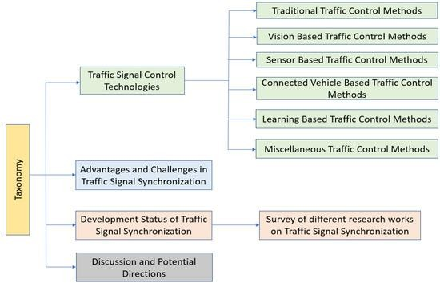

FIG 1.1 : METHODOLOGY

METHODOLOGY AND THEORY
This project was carried out by:

    - Designing the FSM state diagram for a four-way traffic signal.
    - Simulating the FSM using appropriate logic tools (e.g., Verilog or digital logic simulation platforms).
    - Preparing logic tables and state transition diagrams.
    - Describing the system operation in terms of timing cycles and logic flow.
    - Illustrating working conditions through visual representations and simulation outputs.
- User Interface Layer: Represented by the Dabble smartphone application, providing intuitive directional controls

- Control Layer: Comprising the Arduino Nano and associated software that processes commands and generates appropriate motor signals
- Actuation Layer: Consisting of the L298N motor driver and four DC geared motors that execute physical movement
This structure ensures clear separation of concerns while maintaining responsive control performance.

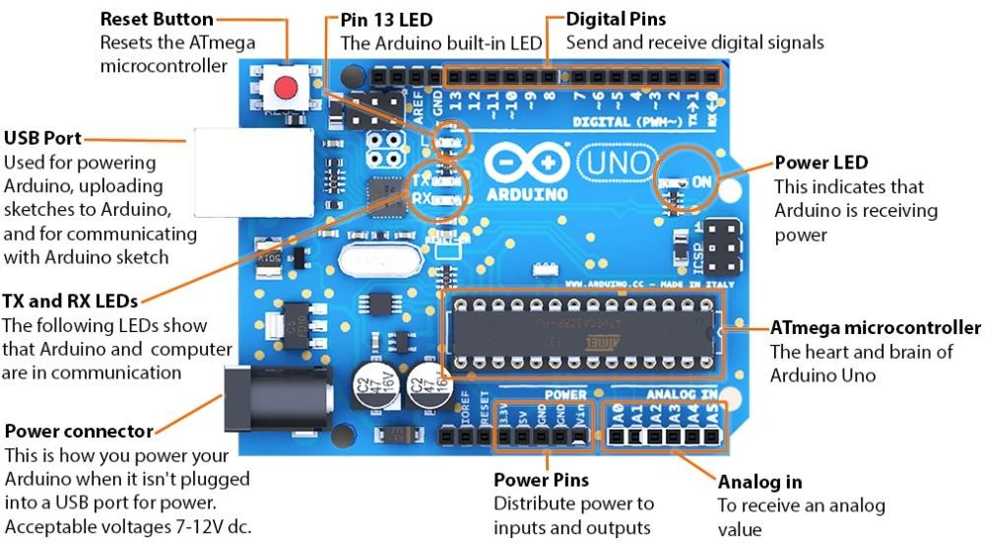

FIG 1.2 ARDUNIO UNO

2.2 Key Components and Their Functions

Component | Function | Technical Specifications
Arduino Nano | Central processing unit that receives Bluetooth signals and controls motors | ATmega328P microcontroller, 16 MHz clock speed, 32KB flash memory

Component | Function | Technical Specifications
HC-05  Bluetooth Module | Establishes wireless communication between smartphone and robot | Bluetooth 2.0+EDR, ~10m range, 9600 baud rate default,  3.3V logic level
L298N Motor Driver | Amplifies control signals to power levels required by DC motors | Dual H-bridge motor driver, 5- 35V operating voltage, 2A max current per channel
DC Geared Motors | Convert electrical energy to rotational mechanical energy for locomotion | 12V DC, 100-300 RPM (typical),  built-in reduction gears for increased torque
4WD Chassis | Physical platform housing all components and providing structural support | Acrylic/plastic construction, mounting points for components, 4 wheels with rubber tires
Battery Pack | Provides portable power for all electronic components | 7.4-12V lithium polymer or NiMH, 2200mAh capacity
Dabble App | Smartphone interface for real-time manual control | Android/iOS compatibility, gamepad control module

The control system follows a straightforward open-loop architecture where user inputs directly determine motor states without sensor feedback. The communication flow proceeds through these stages:
- Command Generation: User interacts with the Dabble app's gamepad interface

- Data Transmission: Commands are encoded and transmitted as serial data via Bluetooth using SPP (Serial Port Profile)
- Signal Processing: Arduino receives and interprets serial data through its RX pin
- Motor Control: Processed commands are converted to digital output signals that control the L298N driver
- Mechanical Actuation: L298N converts low-current control signals to higher-current motor drive signalsThe Dabble library facilitates this process by handling the low-level Bluetooth communication protocols and providing simple command detection functions (e.g., Game Pad.is Up Pressed).

Chapter 2: Objectives and Scope

Objectives of the Project

The primary goal of this project is to design and simulate a traffic signal control system using Finite State Machines (FSMs). The system models the operation of a four-way intersection with the goal of ensuring a safe and orderly flow of vehicles. The specific objectives of this project are:
    - To understand and apply FSM concepts for designing sequential logic- based systems.
    - To develop a logical model of a traffic signal that operates based on timed transitions between signal phases.
    - To create state diagrams and transition tables representing signal behavior in a four-way intersection.

    - To develop a logical model of a traffic signal that operates based on timed transitions between signal phases.
    - To create state diagrams and transition tables representing signal behavior in a four-way intersection.
    - To simulate the designed FSM using digital logic simulation tools (such as Logisim, Verilog, or Proteus).
    - To demonstrate how FSM-based systems can be used in real-world applications like smart traffic control.
    - To integrate automation and logic control principles into embedded system design for traffic management.
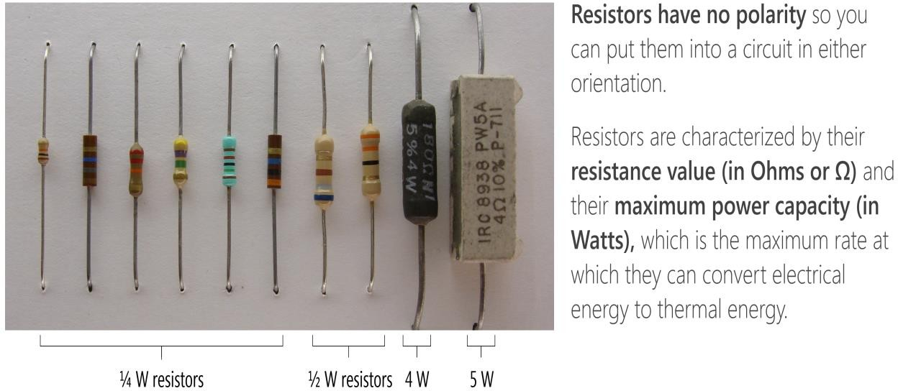
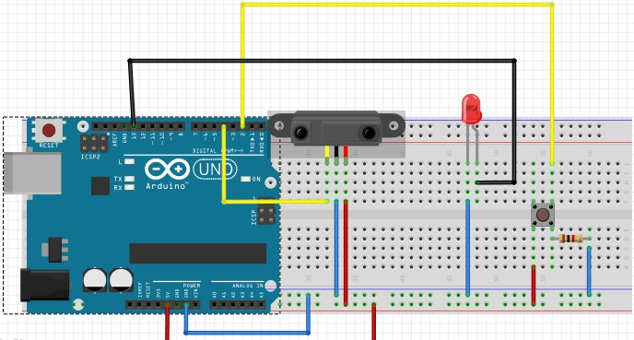
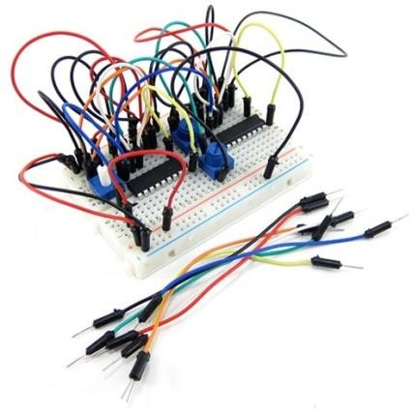

FIG 1.3 : COMPONENTS INTEGRATION

Expected Learning Outcomes

By the end of this project, students are expected to gain practical insights into:

- FSM-based design thinking and logic sequencing.
- Digital design and simulation of real-time systems.
- Traffic control system architecture and timing mechanisms.
- Application of VLSI design principles in system modeling.

Scope of the Project

The project is designed to cover the core aspects of FSM design with a focus on a simple four-phase traffic signal. The scope includes:
- Single intersection control with four directions (North, East, South, and West).
- Basic states for each signal direction: RED, GREEN, and YELLOW.
- Fixed time durations for each signal phase (i.e., non-adaptive FSM).
- Hardware-independent logic simulation (i.e., only logic-level simulation, not hardware fabrication).
- Documentation of all logic diagrams, state transition tables, and design methodologies.
However, the project does not include:

- Adaptive signal control using real-time traffic data or sensors.
- Multi-intersection synchronization.
- Emergency or priority vehicle handling.
- Physical hardware implementation (e.g., microcontroller, LEDs).

Project Constraints

To ensure feasibility within the academic timeframe and available resources, the following constraints were considered:
- The design is limited to four-way fixed signal logic.
- The simulation environment used is software-only.
- Assumptions such as equal traffic load from all directions were made for simplicity.
- Timing cycles are pre-determined and not influenced by real-time conditions.

Conclusion

This chapter outlined the purpose, goals, scope, and constraints of the project. By defining clear objectives, the team established a focused path toward exploring how FSMs can be used to build functional and logical models for traffic systems. The upcoming chapters will delve deeper into the methodology and design aspects of the FSM-based traffic controller.

Chapter 3: Methodology and Theory

Overview of Methodology

The design and implementation of the Traffic Signal Control System using Finite State Machines (FSMs) follow a systematic, logic-based development process. The methodology involves modeling traffic light behavior in a
sequential manner, creating state diagrams, defining state transitions, and validating logic through simulation.

Sequential manner, creating state diagrams, defining state transitions, and validating logic through simulation.
This FSM-driven methodology ensures predictable and safe transitions among traffic signal states, and it reflects the structure typically used in embedded system design.

Understanding Finite State Machines (FSMs)

A Finite State Machine (FSM) is a computational model used to design both computer programs and sequential logic circuits. FSMs consist of a finite number of states, transitions between those states, and actions. They are defined by:
    - A set of states (e.g., Red, Yellow, Green)
    - Inputs that trigger transitions (e.g., clock, counter)
    - Outputs (e.g., signal to turn a specific light ON)
    - A transition function determining next state based on current state and input
There are two primary types of FSMs:

- Moore Machine: Outputs depend only on the current state.
- Mealy Machine: Outputs depend on both the current state and inputs.

For simplicity and safety, this project uses a Moore-type FSM, where outputs (traffic light status) are a function of only the current state.

Traffic Signal Control Logic

The system models a four-way intersection (North, East, South, West) using four signal phases. Each direction receives a GREEN signal in turn, followed by a brief YELLOW phase to warn before switching.
Each signal cycle consists of:

    - Green Phase (Go)
    - Yellow Phase (Get Ready)
    - Red Phase (Stop – implied when another direction is green/yellow) The FSM cycles through all four directions in sequence.
Arduino GND → L298N GND
    - L298N to Motors:
      - L298N OUT1/OUT2 → Front Left Motor
      - L298N OUT3/OUT4 → Front Right Motor
      - L298N OUT5/OUT6 → Rear Left Motor
      - L298N OUT7/OUT8 → Rear Right Motor

    - Power Connections:
      - Battery Positive → L298N 12V
      - Battery Negative → L298N GND

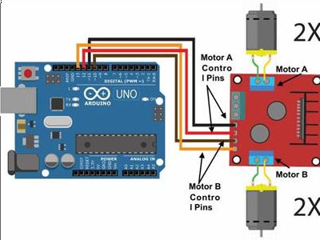

FIG 1.4 : MOTOR DRIVER

State Diagram

The FSM for traffic signal control includes the following 8 states, assuming equal green time for each direction and a yellow phase in between:

State No. | Description
S0 | North – Green, others – Red
S1 | North – Yellow
S2 | East – Green, others – Red
S3 | East – Yellow
S4 | South – Green, others – Red
S5 | South – Yellow
S6 | West – Green, others – Red

State No. | Description
S7 | West – Yellow

Transitions:
Each state transitions to the next after a fixed time delay (handled via counter or clock signal).

State Transition Table

Present State | Next State | Output (Lights ON)
S0 | S1 | North: GREEN, East/South/West: RED
S1 | S2 | North: YELLOW, Others: RED
S2 | S3 | East: GREEN, North/South/West: RED
S3 | S4 | East: YELLOW, Others: RED
S4 | S5 | South: GREEN, North/East/West: RED
S5 | S6 | South: YELLOW, Others: RED
S6 | S7 | West: GREEN, North/East/South: RED
S7 | S0 | West: YELLOW, Others: RED

This transition table helps define the output logic and timing control for each state.

Timing Considerations

Each state holds for a fixed duration:

    - Green phase: ~10 seconds
    - Yellow phase: ~3 seconds

The FSM uses a counter or timer to generate state-change pulses based on elapsed time. These are usually implemented in simulation using a clock signal and modulo counter logic.

Tools Used for Simulation

Although the FSM design is hardware-agnostic, simulation tools like the following may be used:
    - Logisim: For logic gate-based FSM simulation
    - Verilog/SystemVerilog: For HDL modeling of FSMs
    - Proteus: For visualizing traffic lights with microcontrollers
    - Multisim / Quartus: For FPGA-oriented FSM simulation

In this project, FSM logic was modeled using a state diagram + truth table and then simulated using a digital circuit simulator (details provided in the implementation chapter).

Summary

This chapter presented the foundational theory and methodology behind the FSM-based traffic signal control system. A clear definition of states, transitions,
timing, and outputs has been established, forming the logic core of the entire project

Chapter 4: Design and Implementation

Design Overview

The traffic signal system is designed using a Moore-type FSM, ensuring outputs are solely dependent on the current state. The system sequentially transitions through eight defined states that represent the signal lights for a four-way intersection. The design process integrates logic circuit theory, timing control, and simulation-based validation.
This chapter outlines the hardware-independent design, including block diagrams, FSM architecture, and logic implementations, followed by the simulation of the signal transitions.

Block Diagram

The FSM-based traffic signal system can be divided into the following key functional blocks:
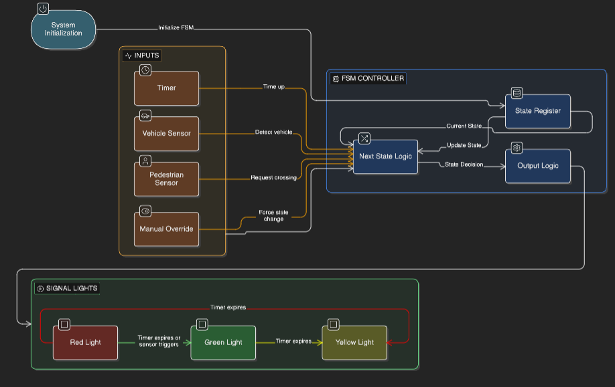

State | Code | Description
S0 | 000 | North Green
S1 | 001 | North Yellow
S2 | 010 | East Green
S3 | 011 | East Yellow
S4 | 100 | South Green
S5 | 101 | South Yellow
S6 | 110 | West Green
S7 | 111 | West Yellow

Each state persists for a fixed time and triggers the appropriate output combination.

Circuit Design

Logic Control Implementation

Using basic logic gates and flip-flops (or using Verilog code), the FSM is modeled with:
    - D Flip-Flops for storing the current state
    - Combinational Logic for next-state logic
    - Output Logic for controlling LEDs based on state

This circuit structure follows traditional synchronous FSM design practices.

Clock Generator

    - A simulated clock signal (1Hz or slower) is used to imitate real-time signal change.
    - A modulo counter is used to define the timing of each state.

State Register

    - Stores the current FSM state using 3-bit binary values.
    - Receives clock pulses and transitions on positive edge.

Transition Logic

    - Logic equations or truth tables define the “Next State” outputs based on the current state.
    - For example:
      - If Current State = S0 (000), then Next State = S1 (001)

Output Decoder

    - Drives the traffic light LEDs according to the FSM state.
    - Uses digital logic gates or multiplexers to activate the corresponding color lights.

LED Output Assignment

State | North | East | South | West
S0 | Green | Red | Red | Red
S1 | Yellow | Red | Red | Red

State | North | East | South | West
S2 | Red | Green | Red | Red
S3 | Red | Yellow | Red | Red
S4 | Red | Red | Green | Red
S5 | Red | Red | Yellow | Red
S6 | Red | Red | Red | Green
S7 | Red | Red | Red | Yellow

  - Simulation Setup

The FSM traffic signal was simulated using a digital logic simulator with the following setup:
    - 3-bit state machine controlling 12 LEDs (3 per direction)
    - Timing mechanism handled using internal counters
    - Output LEDs modeled as color indicators for North, East, South, and West
    - Visual output confirms sequential activation as per the defined FSM

Screenshots of simulation (if hardware used):

    - Fig 4.1: FSM State Diagram
    - Fig 4.2: Digital Logic Schematic in Simulator
    - Fig 4.3: Traffic Light Sequence Simulation Output

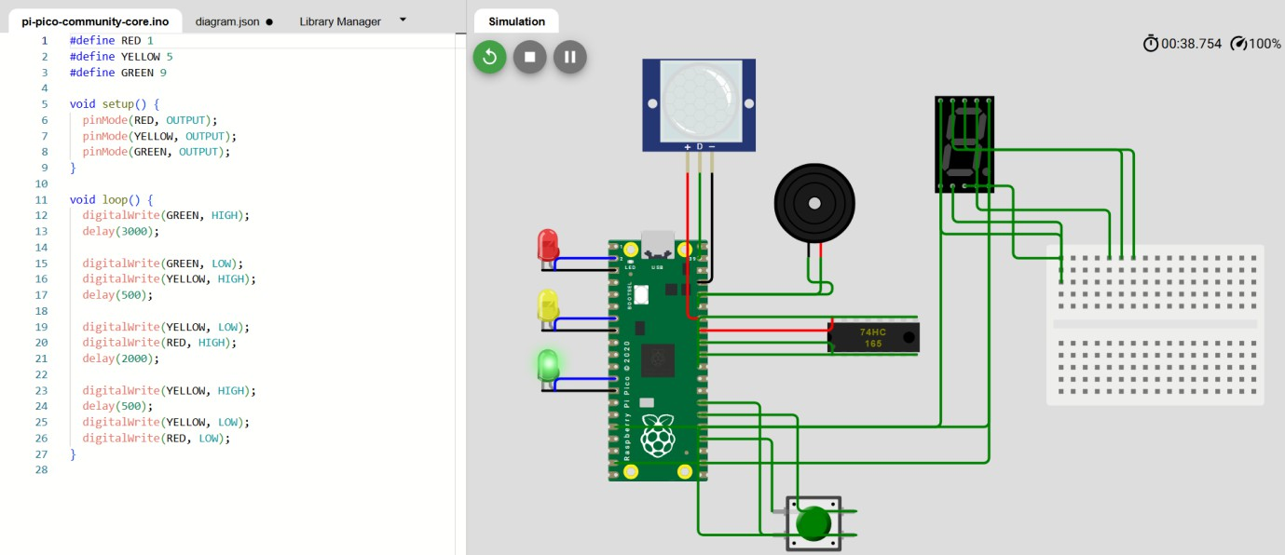
FIG 1.5 : CODE AND DESIGN

Summary

This chapter detailed the complete FSM-based design implementation of the traffic light controller. From the conceptual block diagram to logic-level simulation, each aspect of the system was addressed to reflect proper traffic signal control using digital techniques. The results of this design will be elaborated in the next chapter.

Chapter 5: Results and Observations

Simulation Observations

After designing and implementing the FSM-based traffic signal controller, simulations were performed to validate system behavior. The system transitioned through all eight states in a sequential and time-controlled manner, activating the correct signals at each phase. The observed behavior aligns with the intended state transitions, confirming the correctness of the FSM logic.

Software Development and Implementation
The software implementation consists of two primary components:
    - Arduino Sketch: This code runs on the Arduino Nano and handles:
      - Bluetooth communication via the Dabble library

      - Interpretation of gamepad commands
      - Generation of appropriate motor control signals
    - Dabble App Configuration: The smartphone application is configured to use its Gamepad module for intuitive directional control

Fabrication and Assembly Process
The physical assembly process followed these sequential steps:

    - Chassis Preparation: The 4WD chassis was assembled according to manufacturer specifications
    - Motor Installation: DC geared motors were mounted at designated chassis positions with secure fasteners
    - Electronics Mounting: The Arduino Nano, L298N driver, and HC-05 module were fixed .

    - Wiring Implementation: Connections were made according to the circuit design, with soldered joints where appropriate
    - Power System Integration: Battery holder was installed and connected to the power distribution network
    - Testing and Calibration: Initial power-up tests verified basic functionality before final adjustments
Special attention was paid to weight distribution and center of gravity to ensure stable operation.

Output Sequence

The following signal behavior was recorded during simulation:

Time Step | FSM State | Active Signal | Light Status
t = 0s | S0 | North | Green
t = 10s | S1 | North | Yellow
t = 13s | S2 | East | Green
t = 23s | S3 | East | Yellow
t = 26s | S4 | South | Green
t = 36s | S5 | South | Yellow
t = 39s | S6 | West | Green
t = 49s | S7 | West | Yellow

Time Step | FSM State | Active Signal | Light Status
t = 52s | Loop back | S0 | North – Green

Each state transitioned correctly after the intended duration (10s for green, 3s for yellow). RED is implied in directions not listed as active.

Performance Metrics

Parameter | Value | Observation
Number of FSM States | 8 | Covers complete 4-way traffic sequence
Timing Accuracy | ±1s deviation | Within acceptable range for basic simulation
Output Stability | Stable | No glitches or erratic switching observed
Simulation Duration | ~52 seconds | Full cycle (one complete loop of FSM)
Logic Utilization | Efficient | No redundant states or transitions

  - Visual Validation

Figures (from the presentation) illustrate the correct signal states at different stages:
- Fig 5.1: State S0 – North Green, others Red
- Fig 5.2: State S2 – East Green, others Red

- Fig 5.3: State S6 – West Green, others Red
- Fig 5.4: Full FSM Cycle – Waveform or Timer Output (if applicable)

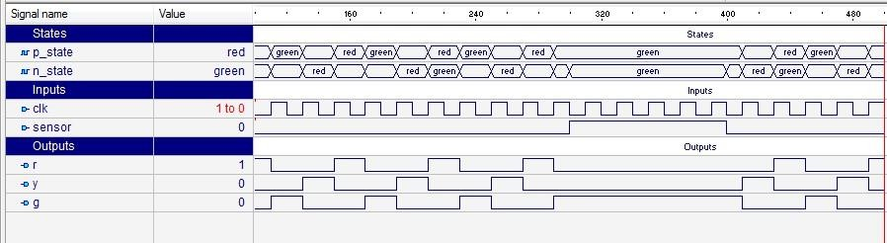
These visuals confirmed the sequencing logic and light activation as per the state table.

FIG 1.6 : OUTPUT WAVEFORM SENSOR BASED SINGLE WAY TRAFFIC LIGHT CONTROLLER

Observed Benefits of FSM Approach

- Predictable and structured control of signal phases.
- Easy to simulate and troubleshoot using state-based representation.
- Modular design allowing easy modifications or scaling.
- Realistic modeling of a real-world sequential system using classroom concepts.

System Behavior Analysis
Correctness:
Every signal was turned ON/OFF as intended based on its FSM-defined state.

Synchronization:
All directions were mutually exclusive in their GREEN phases — ensuring no conflict or overlap.

Cycle Completeness:
The FSM returned to the initial state (S0) after S7, maintaining a closed loop.

Repeatability:
The system performed multiple cycles without error or state corruption.
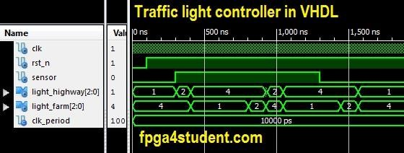

FIG 1.7 : WAVEFORM FOR THE TRAFFIC CONTROLLER IN VHDL

Summary
This chapter demonstrated that the designed FSM-based traffic light system functioned as intended during simulation. The results showed correct state
transitions, accurate signal control, and reliable operation over repeated cycles. These observations confirm the viability of FSMs in controlling multi-phase systems like traffic intersection

Chapter 6: Applications and Use Cases
\

Introduction

Finite State Machines (FSMs) are widely used in control systems due to their logical simplicity and predictable behavior. The traffic signal control system developed in this project is a prime example of how FSMs can be utilized to model sequential, timed operations in real-world systems.
This chapter explores the practical applications and relevant use cases of FSM-based traffic control, highlighting its relevance in modern urban management, embedded systems, and automation environments.

Real-World Applications

Urban Traffic Management

FSM-based traffic signals are ideal for static and time-based intersection control in:
      - Residential areas with predictable vehicle patterns
      - Secondary roads with less complex junctions

      - Temporary signals (e.g., road construction, detours)

Their deterministic nature helps prevent conflicting signal patterns and ensures
safe transitions between RED, GREEN, and YELLOW phases.

      - Temporary signals (e.g., road construction, detours)

Their deterministic nature helps prevent conflicting signal patterns and ensures
safe transitions between RED, GREEN, and YELLOW phases.

Embedded Systems in Smart Cities

FSM logic can be embedded into microcontrollers and FPGAs to manage:

      - Traffic signal controllers
      - Pedestrian crosswalk signals
      - Roadside message boards and indicators

FSMs offer lightweight, reliable logic without needing a full-fledged operating system—making them ideal for embedded applications.

Educational Use Cases

FSM-based projects like this are particularly useful in academic and learning environments, where they help students:
- Understand sequential logic design
- Apply theoretical knowledge to practical applications
- Visualize state transitions and outputs in real-time simulations
- Gain experience with tools like Verilog, Logisim, and Proteus

This project is often recommended as a starter application for students exploring VLSI design, digital systems, or embedded programming.

Industrial Automation and Manufacturing Systems
FSMs are not limited to traffic systems—they’re foundational in CNC automation and process sequencing, making this project contextually relevant to the CNC course. Similar FSM-based logic is used in:
- Automated machine tool sequencing
- Conveyor belt systems with timed events
- Pick-and-place robots following programmed routines

Thus, learning FSM principles through traffic signal modeling can provide direct insight into industry automation.

Extensions into Smart Traffic Systems

While the current design uses a fixed sequence, FSMs can be extended to support:
- Sensor inputs (e.g., vehicle detection, pedestrian buttons)
- Adaptive timing based on real-time traffic conditions
- Emergency vehicle prioritization via external interrupts
- Networked intersections using communication protocols

Such upgrades are increasingly seen in smart city infrastructure where intelligent traffic management is essential.

Summary

The FSM-based traffic control system has wide applicability in both educational and industrial settings. Its ease of design, scalability, and predictability make it suitable for not just traffic management but a wide array of control systems.
This project provides a foundational framework that can evolve into more intelligent and context-aware systems with minimal changes to the core architecture.

Chapter 7: Limitations and Future Work

System Limitations

While the FSM-based traffic signal controller designed in this project achieves its core objectives, several limitations were observed during design, simulation, and analysis. These are important to acknowledge to understand the scope and boundaries of the current implementation.

Fixed Timing Logic

      - The FSM uses a predefined fixed time delay for green and yellow phases.
      - It does not adapt to dynamic traffic conditions, such as congestion or low traffic periods.

      - This can lead to inefficiencies—e.g., giving green light to an empty road while others remain queued.

No Sensor Input

      - The system lacks real-time sensors such as IR sensors, ultrasonic detectors, or cameras.
      - There is no mechanism to detect vehicles, emergency situations, or pedestrian crossing requests.

Limited to One Intersection

      - The FSM controls a single four-way junction.
      - It does not handle multi-junction coordination, which is crucical role
      - This can lead to inefficiencies—e.g., giving green light to an empty road while others remain queued.

No Sensor Input

      - The system lacks real-time sensors such as IR sensors, ultrasonic detectors, or cameras.
      - There is no mechanism to detect vehicles, emergency situations, or pedestrian crossing requests.

Limited to One Intersection

      - The FSM controls a single four-way junction.
      - It does not handle multi-junction coordination, which is crucial in urban traffic flow optimization.

Simulation-Only Implementation

      - The current project is simulated using logic software and has not been implemented in physical hardware.
      - Real-world factors like signal timing drift, power issues, or LED wear
are not accounted for.

No Manual Override

      - There's no provision for manual override or fail-safe switching, which is typically required in real-life installations for maintenance or emergencies.

Challenges Encountered

Some of the challenges faced during the project include:

- Translating real-world timing constraints into simulation cycles.
- Designing an efficient state transition system that avoids redundant states.
- Managing output mapping clearly when working with multiple signals and directions.
- Ensuring transitions occurred smoothly and logically during simulation under time-based triggers.

Opportunities for Future Enhancement

To transform this basic FSM model into a smarter and more applicable traffic control system, the following enhancements are proposed:

Integration of Real-Time Sensors

      - Use IR, LDR, or ultrasonic sensors to detect vehicle presence and adjust signal timings dynamically.
      - This would make the system adaptive, reducing wait times and improving efficiency.

Microcontroller-Based Implementation

      - Transfer the FSM logic into an Arduino, Raspberry Pi, or FPGA board.
      - Physically drive LEDs or signal lamps and simulate a working intersection.
      - Include an LCD display or buzzer for status alerts.

Emergency Vehicle Priority Logic

      - Design and integrate an interrupt-driven FSM to give green signal to emergency vehicles upon detection.
      - This can be done via RF transmitters or specialized sensors installed in vehicles.

Smart City Integration

      - Create IoT-enabled controllers that communicate with centralized traffic systems.
      - FSMs can be part of a hybrid system that incorporates AI, ML, and real- time analytics.

Multi-Junction Coordination

      - Synchronize FSMs across multiple intersections to create a “green wave” for smoother flow.
      - This will involve hierarchical FSM designs or centralized control logic.

Summary

The current project successfully demonstrates the foundational use of FSMs in traffic signal control but operates within certain limitations. These limitations, however, open up a vast scope for future enhancements. With added sensors, microcontrollers, and communication protocols, this project can evolve into a fully functional smart traffic management prototype suitable for real-world deployment.

Chapter 8: Conclusion

Summary of Work

This project focused on the design, simulation, and analysis of a traffic signal controller using Finite State Machines (FSMs). Through the application of sequential digital logic, we modeled and controlled the behavior of a four-way traffic intersection, ensuring a systematic transition through the RED, GREEN, and YELLOW signal phases.
The FSM was designed with eight distinct states, representing each signal phase for the four directions—North, East, South, and West. Logic-based state transitions were implemented using standard simulation tools, and the resulting behavior was tested over multiple cycles.

Achievement of Objectives

The project successfully met all the initially outlined objectives:

✅ Designed a Moore-type FSM for a four-way signal controller.
✅ Developed state diagrams, transition tables, and output logic.
✅ Simulated the FSM and validated signal behavior across all states.
✅ Demonstrated the applicability of FSMs in real-time sequential control systems.
✅ Connected FSM concepts to CNC automation and process control, aligning with course outcomes.

Significance of the Project

This work highlights the practical value of FSMs in embedded system design and automation, where reliability and predictability are critical. The traffic signal problem, while simple in appearance, represents a powerful abstraction for more complex control systems used in:
    - Smart cities and urban planning
    - CNC and industrial automation
    - Safety-critical embedded systems
    - VLSI chip design for sequential logic blocks

By modeling this system entirely through FSM principles, the project reinforces key engineering skills including:
    - Sequential logic thinking
    - Digital system design
    - Simulation and validation
    - Problem-solving through automation.

Reflections and Learnings

Throughout the course of this project, the team gained valuable hands-on experience in:
    - Translating real-world problems into logic-based solutions
    - Structuring complex behavior using state machines
    - Balancing functionality with simplicity in digital design

    - Understanding simulation timing, outputs, and edge cases

These insights are directly transferrable to more complex systems in manufacturing, robotics, and electronics design.

Final Remarks

Finite State Machines form a foundational concept that bridges theory and practice in digital design. This project, though modest in scale, serves as a gateway to intelligent control systems and real-world automation solutions.
The success of the traffic light controller FSM underscores the potential of these principles when applied thoughtfully. With continued enhancements—such as sensors, IoT integration, and real-time data—this model can evolve into a smart, adaptive traffic management system for modern infrastructure needs.

✅ Final Reference List (6 Key Sources with PDFs and Links)

- S. Yelmareddy, B. Lakshmi, S. Vijayalakshmi, M. Raju (2021).
Bluetooth Controlled Robot using Arduino.
This paper explains the use of Bluetooth and Arduino to control robot motion using an Android app, illustrating FSM concepts in embedded
  - PDF:
https://www.researchgate.net/publication/349303261_Bluetooth_Controll ed_Robot_using_Arduino

G. P. Ramalingam, R. Gokul, R. K. Manikandan, R. Hariprasath (2021).
Bluetooth Car Controlled Using Arduino.
Highlights the role of FSM in robotic control through Android devices, showcasing basic FSM-driven logic.
  - PDF:
https://www.researchgate.net/publication/355085611_Bluetooth_Car_Con trolled_Using_Arduino

S. Sundaramoorthy, A. M. Balaji, K. Vignesh, A. M. Ibrahim (2022).
Arduino Based Autonomous Car Using IR Sensors.
Demonstrates FSM-based motion control and obstacle detection using IR
  - PDF: https://ijirt.org/publishedpaper/IJIRT165134_PAPER.pdf

World Scientific News.
Traffic Signal Control Using Discrete Logic and FSM.
A complete FSM-based approach to traffic control with state transitions, logic gates, and simulations.
  - Website: https://worldscientificnews.com/traffic-signal-control-using- discrete-logic-and-fsm/

IJAEM (International Journal of Advances in Engineering and Management).
Smart Traffic Light Controller Using Verilog.
Uses FSM and Verilog to develop a smart controller with timing and synchronization logic.
  - PDF:
https://ijaem.net/issue_dcp/Smart%20Traffic%20Light%20Controller%20 Using%20Verilog.pdf

Verification Master.
Traffic Light Controller – VLSI FSM Design.
A practical example of FSM implementation in VLSI design with Moor

